2015-2016 Pre-Calculus
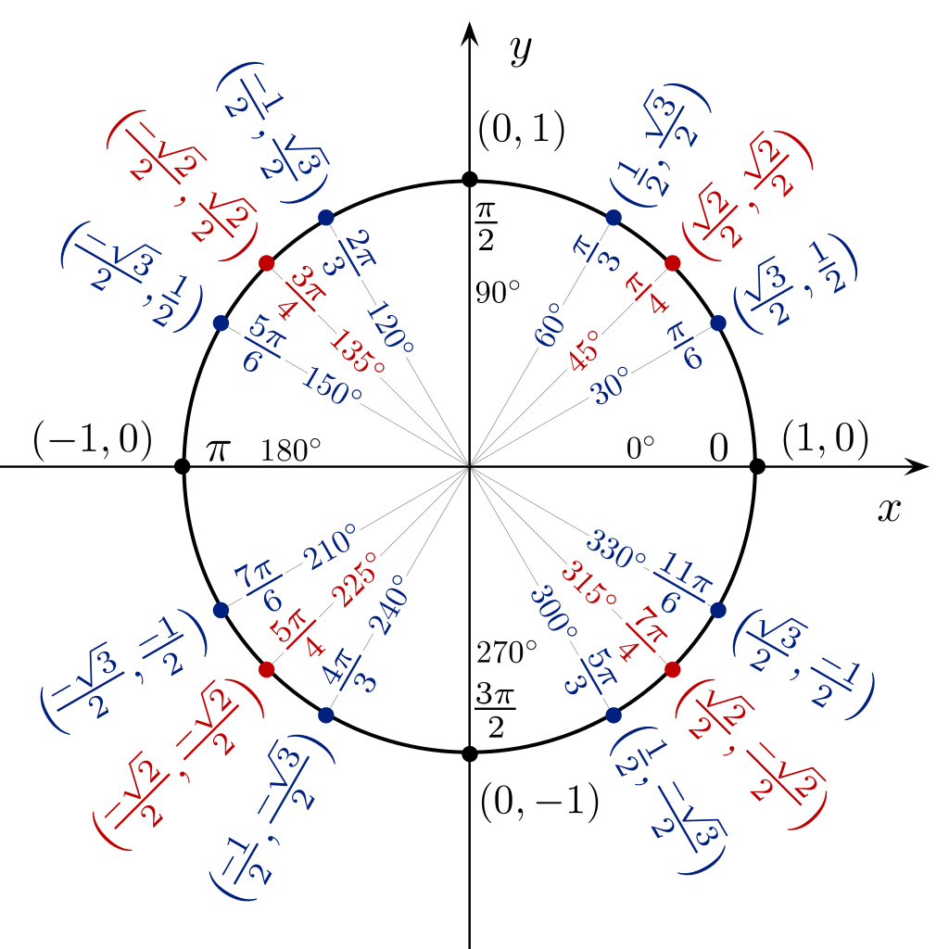

Instructor: Mrs. Grothman
Phone Number: (602) 496-3091
Weebly: mmcdonaldasuprep.weebly.com
Email: mmcdon10@asu.edu

Course Description

This Pre-Calculus course combines the study of Trigonometry, Elementary Functions, Analytic Geometry, and Math Analysis topics as preparation for calculus. Topics typically include the study of complex numbers; polynomial, logarithmic, exponential, rational, right trigonometric, and circular functions, and their relations, inverses and graphs; trigonometric identities and equations; solutions of right and oblique triangles; vectors; the polar coordinate system; conic sections; Boolean algebra and symbolic logic; mathematical induction; matrix algebra; sequences and series; and limits and continuity.
Required Materials

You should have the following materials with you every day in class:
- Math Notebook (lined/graph paper)
- Math Folder or Binder
- Pencils and Erasers
- Scientific Calculator
The Math notebook and folder should be specific to Math. It should contain class notes, daily reflections, handouts and homework assignments.

Attendance

Given the nature of our block scheduling and the great extent of collaborative work, it is important that you attend class every day. It is very difficult to “make up” days for which you are absent and mastery of class content is directly related to class attendance. In the event of an absence, you are responsible for getting class notes from a classmate and checking with the instructor for missed assignments. This should be done before the next class meeting.

Class Expectations- SLANT!

You are expected to contribute to a positive daily learning environment by:
- Being in your seat when class starts and immediately working on the warm-ups
- Actively participating in learning.
- Bringing your journal, pencil, and calculator.
- Completing all in class assignments and homework
- Helping your colleagues in their quest to learn.
- Looking and listening to someone when they are talking
- Following guidelines regarding use of classroom facilities and equipment.
- Following school-wide guidelines.

When you choose to ignore classroom guidelines, you will receive:
- A verbal warning
- Private conversation with Mrs. Grothman
- An intervention call home
- Lunch detention
- Conference with parents and teacher
- A referral to the Dean of Students
- Saturday detention

When you choose to follow classroom guidelines, you may:
- Receive verbal praise
- Be the subject of a commendation call home
- Positive note mailed home to parents

Start of Class Procedures

Students should enter the classroom prior to the designated start time. Upon entering the classroom please go to your assigned seat and attend to the “Warm-up” task that will be displayed on the board or screen. You will have five (5) minutes to complete the task in your science journal/notebook.

End of Class Procedures

Students will stay in their seats working on the assigned task until I notify you that it is time to leave class. Do not pack up before I announce it is time.

Grading

Your grade will be based on mastery of standards in Cambridge AS Mathematics. The grade scale is shown in the table to the right:

Grades will be weighted as follows:
Quizzes and Projects: 50%
Exam: 50%

A+ | 97-100%
A | 90-96%
B | 80-89%
C | 70-79%
D | 60-69%
F | 50-59%
I | Incomplete/Unassessed

You may not earn lower than 50%. This a) sufficiently demonstrates that you need further instruction and practice on this standard, and b) allows you a better opportunity to stay engaged in the class and recover your grade.
If you do not complete an assessment, you will receive a zero as a placeholder. However, the assessment must be completed in order to earn a grade percentage for the class. If the exams are not completed, you will not earn credit for the class. Your grade will reflect your achievement and mastery, and your grade cannot be calculated if you have not completed the work.
No points will be deducted for late assignments as we are focused on your mastery of the concepts presented in class.
If you missed an assessment, quiz or test, you will need to fill out a Missing Assessment Form signed by both the student and parent. Excessive missing assessments will warrant a parent/teacher meeting to discuss a plan to ensure your success moving forward. Make up tests and quizzes must be completed outside of class.

Effort Grade
The Effort Grade will be a separate grade that accounts for and assesses the issues of:
- behavior (respect for self, others, and education)
- participation (prepared with materials/supplies, and engaged)
- and effort (complete homework on time, take notes, and study)
- Note: Any changes to the information contained in this syllabus will be announced with fair warning and posted on the Coordinated Science bulletin board.
- Please complete the following and turn in to Mrs. Grothman by Friday, July 31st.
What hour do you have Mrs. Grothman? (Circle one)
Maroon 1 Maroon 2
Student Name (first and last)
Parent(s)/Guardian(s) Name(s)
Relationship to Student
What is the best phone number to contact your parents? (Please indicate whose phone and if home, cell, or work).
Phone: Home Cell Work
Do your parent(s)/guardian(s) have access to email? If yes, what is the best email to contact them at?
Email:
Do you need the email or phone call in Spanish or another language? Yes No
Are there any questions, concerns, or other information you would like me to know?

Student signature
Parent/Guardian signature

